DESIGN OF A TIMER WITH PRESET VALUE AND ALARM TRIGGER
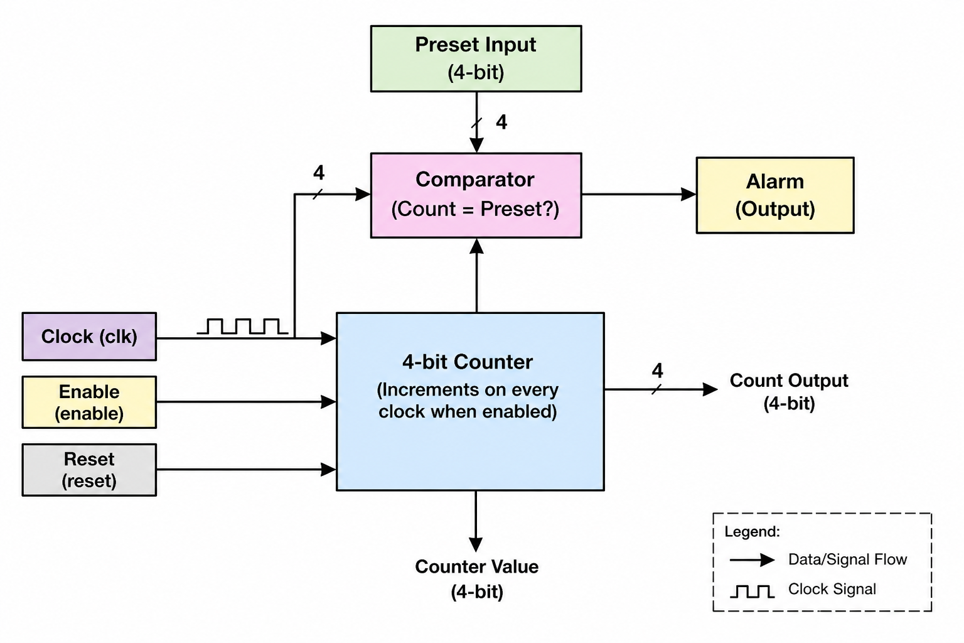
PRESENTED BY:
ANSHITA GOEL
ARTIKA NISHAD

INTRODUCTION:
In digital electronics and VLSI systems, timers are widely used for controlling operations based on time or clock cycles. A timer is essentially a counter that keeps track of clock pulses and performs a specific action when a predefined value is reached. Such timers are used in applications like alarms, traffic lights, embedded systems, and industrial automation.
In this project, a timer is designed using a 4-bit counter that increments on every clock pulse when enabled. The counter starts from zero and continues counting until it reaches a preset value provided as input. Once the preset value is achieved, an alarm signal is generated to indicate the completion of the timing cycle. This design demonstrates the basic working of sequential circuits and helps in understanding concepts like clocking, control signals, and condition-based triggering.

OBJECTIVE:

The main objectives of this project are:
- To design a timer using a counter in Verilog
- To implement a 4-bit incrementing counter
- To generate an alarm signal when count equals preset value
- To understand the role of clock, reset, and enable signals
- To simulate and verify the design using a testbench
- To analyze the working of sequential logic circuits

FEATURES OF THE TIMER:
- 4-bit Counter Design
Uses a 4-bit register to count values from 0 to preset.
- Incrementing Operation
Counter increases by +1 on every clock pulse when enabled.
- Preset Value Input
User can set a target value using a 4-bit input.
- Alarm Trigger Mechanism
Generates an alarm signal when count equals preset value.
- Enable Control
Counter works only when enable = 1, allowing start/stop control.
- Reset Functionality
Resets the counter back to 0 and clears the alarm.
- Synchronous Design
Operates based on clock edges, ensuring stable and predictable behavior.
- Simple and Efficient Implementation
Requires minimal hardware, suitable for FPGA/VLSI applications.
- Testbench Verification
Design is verified using simulation to check correct operation.

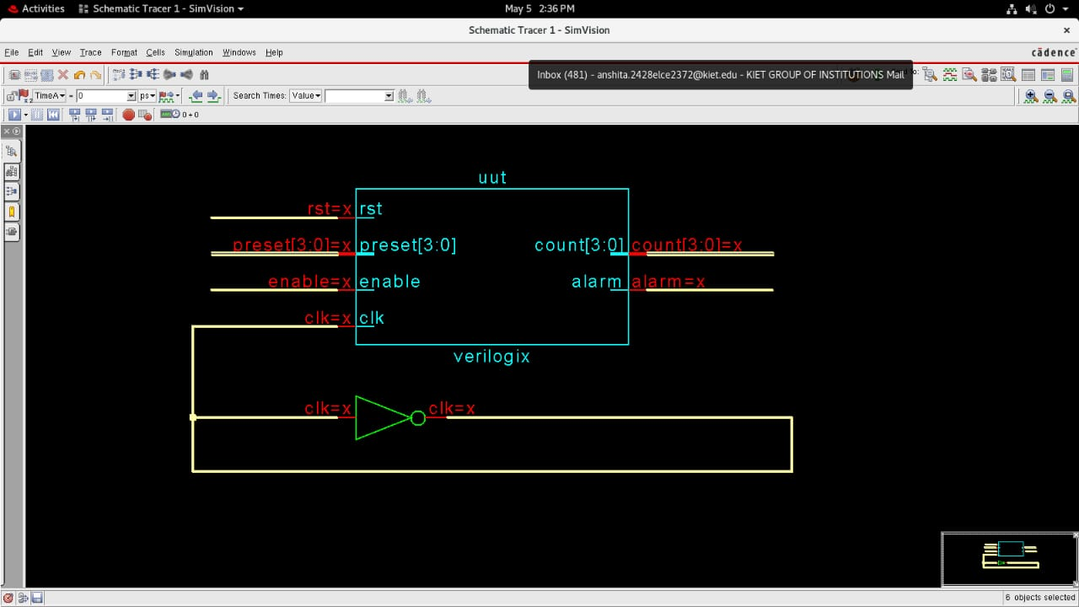

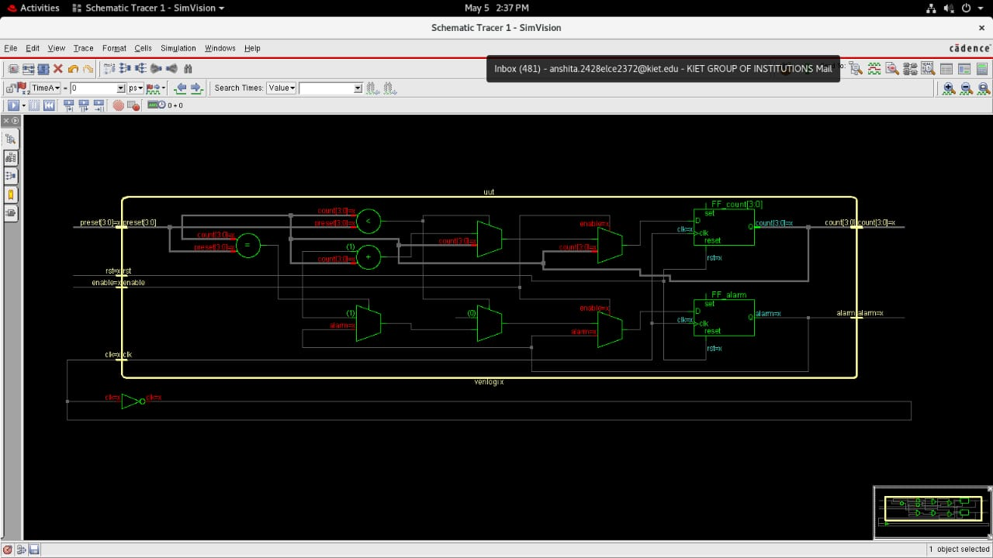
MODULE -WISE DESIGN:
The overall system is divided into smaller functional modules for better understanding and implementation.
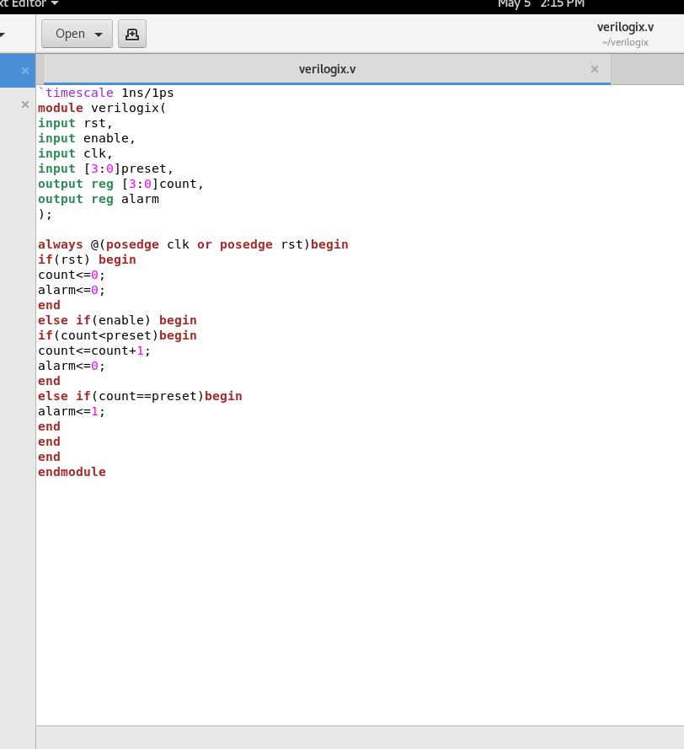

TESTBENCH:
The testbench is used to simulate the hardware behavior by providing a clock and stimulus signals.
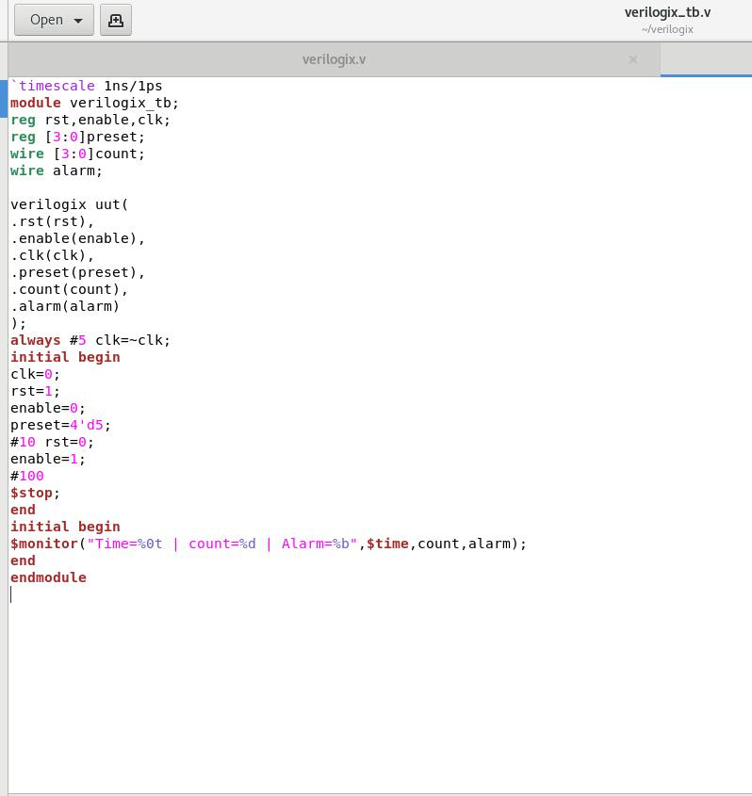

Waveform Signal Analysis
The waveform visualizes the interaction between the control signals and the counter logic over time:
- Clock (clk): A periodic signal with a 10ns period (generated by always #5 clk=~clk in the testbench).
- Reset (rst): Initially, the reset signal is high, which forces both the count and the alarm to 0. After approximately 10ns, rst transitions to 0, allowing the timer to start.
- Enable (enable): This signal is set to high (1) shortly after the reset is released, enabling the counter to increment on each rising clock edge.
- Preset (preset[3:0]): The target value is set to 5 ('h5 or 4'd5).
- Count (count[3:0]): You can see the counter incrementing sequentially: 0 -> 1 -> 2 -> 3 -> 4 -> 5 on every positive edge of the clock.
- Alarm (alarm): This signal stays at 0 while the count is less than the preset. It transitions to 1 once the counter reaches the target
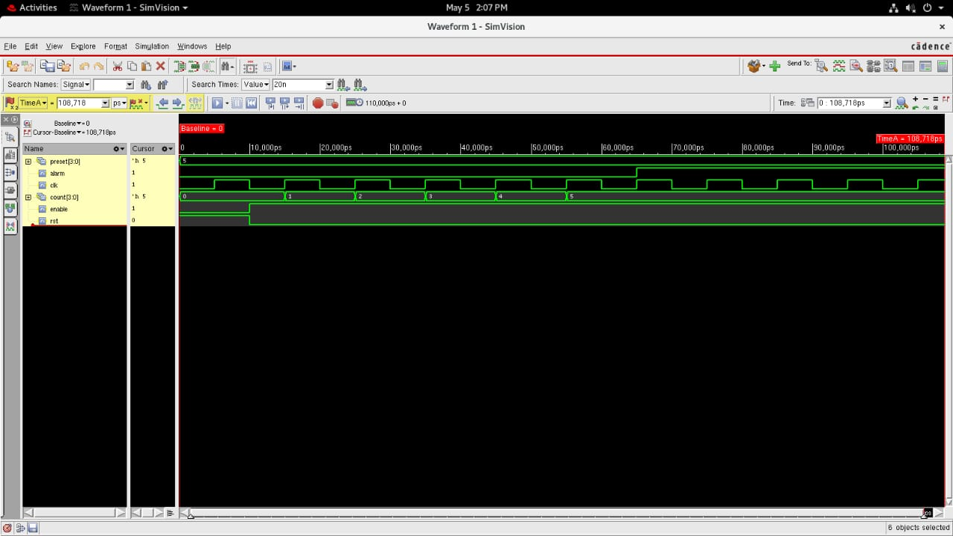
Simulation Results:
The waveform simulation shows the following behavior:
- The preset is set to 5.
- As the clock pulses occur, the count increments from 0 to 1, 2, 3, 4, and finally 5.
- Alarm Trigger: When the count reaches 5, the alarm signal transitions from low to high.
- One-Clock Delay: Observation of the waveform shows that the alarm goes high one clock cycle after the counter reaches the preset value. This is due to the non-blocking assignment (<=) used in Verilog, where the new value of alarm is only updated at the next positive edge of the clock after the count == preset condition becomes true.

Advantages:
- Simple Design: The logic is straightforward and easy to implement for beginners.
- Efficient and Reusable: The module can be easily integrated into larger digital systems.
- Low Resource Usage: Uses very few logic gates, making it ideal for small FPGA or CPLD projects

Applications:
- Digital Clocks: Providing the base counting mechanism for seconds, minutes, or hours.
- Alarm Systems: Triggering a siren or light when a specific time or count is reached.
- Embedded Systems: Used for creating delays or periodic interrupts in microcontrollers.
Limitations:
- Limited Count Range: Being a 4-bit design, it can only count up to 15 (2^4 - 1).
- Delay in Alarm Generation: There is a one-clock cycle delay between the count reaching the target and the alarm turning on.
Future Improvements:
- Increase Bit Width: Expanding to 8-bit or 16-bit to allow for much higher preset values.
- Pause/Resume Feature: Adding a "pause" input to stop the counter without resetting it.
- Loadable Preset: Allowing the preset to be changed dynamically during operation without a full reset.

KEY CHALLENGES:
- Correct Counter Design
Ensuring the counter increments properly on each clock edge without skipping or repeating values.
- Synchronization with Clock
Maintaining proper timing so that all operations occur exactly on the clock edge (avoiding glitches).
- Handling Reset and Enable Signals
Designing logic so that reset correctly initializes the counter and enable properly controls start/stop behavior.
- Accurate Comparator Logic
Ensuring correct comparison between count and preset to trigger the alarm at the right time.
- Avoiding Overflow Issues
Since it is a 4-bit counter, values are limited (0–15), so handling limits properly is important.
- Glitch-Free Alarm Signal
Making sure the alarm output is stable and does not produce unwanted spikes.
- Testbench Verification
Creating proper test cases to verify all scenarios (reset, enable off, different preset values).
- Edge Case Handling
Handling situations like:
  - preset = 0
  - enable toggling during counting
  - reset during operation
Conclusion:
This project successfully demonstrates the design of a programmable timer with an alarm trigger using Verilog HDL. By implementing a simple counter and comparison logic, we created a functional timing system. The simulation confirmed that the design handles reset and enable signals correctly, and it highlighted the importance of understanding non-blocking assignments and their effect on timing delays in digital circuits.

